Instructions for Noise Cals for T-Differentiator

Gray: *Noise_out* DAQ Ch0

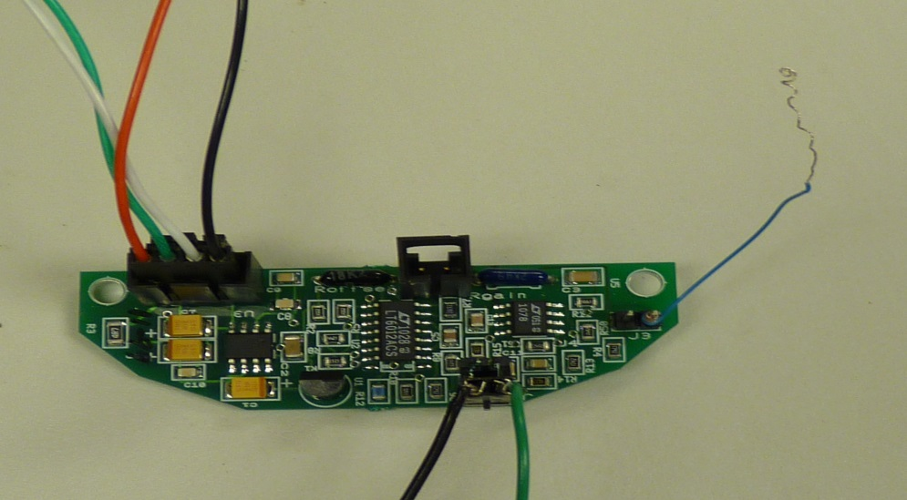

Green: *Noise_in* DAQ Ch1

Blue Wiring

J1

J4

Red: +5 V DC

Black: GND

Figure: Circuit Board of the Thermistor – Differentiator circuit with external wiring

1. Unplug Molex at J1
2. Unwrap Blue wire at J4 Pin1
3. Plug in Molex 4-pin from Test rig after disconnecting connector from ADC board
4. Connect attenuated noise to J4 pin1 (noise ~ 150 mv p-p)
5. Plug noise generator and DAQ into USB
6. Run TNoiseCal to collect 400Hz data for 400,000 points (100 seconds). Calls NoiseDAQ, [Noise_in,Noise_out] = NoiseDAQ(fs,N_samples)
7. Observe plot, is it O.K ?

If yes, save figure and date

If not, diagnose and repeat

1. Remove test connectors and reconnect blue wiring at J4. Reconnect 4-pin molex into the ADC board.